Loan360 App SOP

The following steps outline the procedure for Collection360 mobile application.

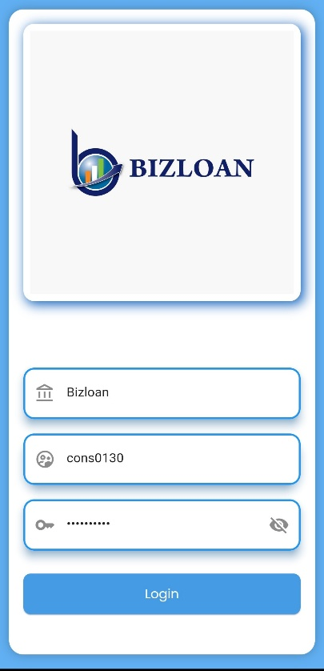
Step 1: Launch the Application: -

- Open the BIZLOAN application on your device.
- Ensure you have a stable internet connection.
Step 2: Identify the Login Screen: -

- You will see the BIZLOAN logo at the top.
- Below the logo, there are three input fields and a “Login” button.
Step 3: Enter the Company/Institution Name: -

- Tap or click the first input field with the bank icon.
- Type in the institution name (e.g., Bizloan).

Step 4: Enter Your Username: -
- Tap or click the second input field with the user icon.
- Enter your assigned username (e.g., cons0130).

Step 5: Enter Your Password: -
- Tap or click the third input field with the key icon.
- Type your password securely.
- You can tap the eye icon to toggle visibility if needed.

Step 6: Submit Login Credentials: -
- Once all fields are filled correctly, press the “Login” button (blue button at the bottom).

Post-Login Dashboard Overview – BIZLOAN Application.

✅ What Happens After Login:
Once you successfully enter your credentials and log in, you are directed to the
Dashboard screen. This is the main hub where you can monitor and manage
loan applications.

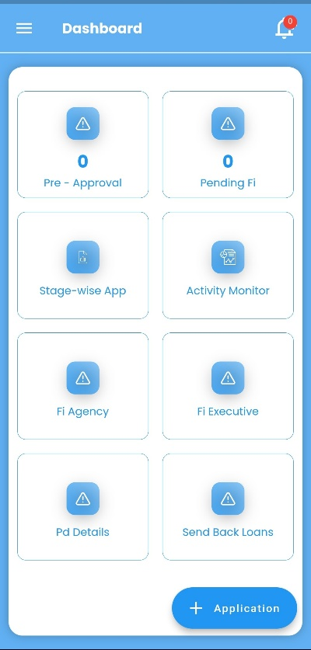

🧭 Key Dashboard Elements Explained:
Feature | Description
Pre-Approval | Shows number of applications that are at the pre-approval stage.
Pending FI | Displays loans that are pending field investigation.
Stage-wise App | Let’s you track applications based on their processing stage.
Activity Monitor | Shows the recent activities, user logs, or system events.
FI Agency | View or manage agencies assigned for field investigations.
FI Executive | Access details or assign tasks to individual field executives.
PD Details | Contains personal discussion information for each loan.
Send Back Loans | Loans that were returned for revision or missing info.

